Gap Analysis:
Adult Asthma Care: Promoting Control of Asthma 2017
Work Sheet

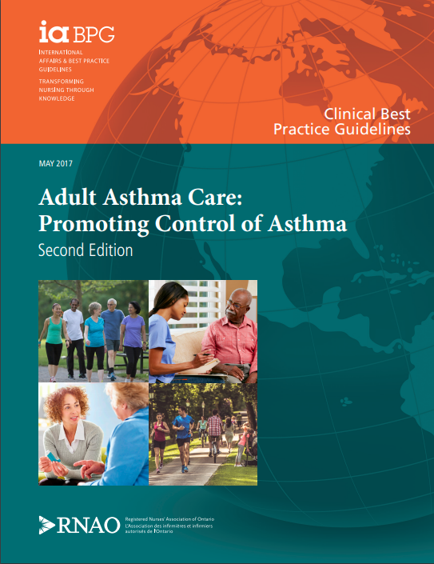
BPG Cover image
This guideline can be downloaded for free at:
https://rnao.ca/sites/rnao-ca/files/bpg/Adult_Asthma_FINAL_WEB.pdf
The RNAO Leading Change Toolkit 3rd Edition
https://rnao.ca/leading-change-toolkit

Date Completed:
Team Members participating in the Gap Analysis:

RNAO Healthy Work Environment Best Practice Guideline Recommendations | Met | Partially Met | Unmet | Notes  (Examples of what to include: is this a priority to our home, information on current practice, possible overlap with other programs or partners)
Recommendations
1.1 At initial encounter, identify adults with an asthma diagnosis by reviewing the health record for an established asthma diagnosis, supported by the use of objective lung function measurements, and by asking two questions:
1. Have you ever been told by a health-care provider that you have asthma?
2. Have you ever used a puffer/inhaler or asthma medication for breathing problems? (V)
1.2a At every encounter, assess the person’s current level of asthma control according to the following criteria:
-Need for a fast-acting beta2 -agonist < 4 doses/week (including for exercise);
- Daytime symptoms < 4 days/week;
- Nighttime symptoms < 1 night/week;
- Normal physical activity levels;
- Mild, infrequent exacerbations;
- No absences from work or school;
- Forced expiratory volume in first second (FEV1 ) or peak expiratory flow (PEF) ≥ 90% of personal best*‡;
- Diurnal PEF variation < 10–15%*‡; and
- Sputum eosinophils < 2–3%*‡.
* Indicates important objective information for a complete assessment of asthma control, but may not be available.
‡ Performed and interpreted within health-care-provider scope of practice (including appropriate knowledge and skills) and in alignment with organizational policies and procedures. (V)
1.2 b For adults with uncontrolled asthma, determine whether the person is currently experiencing an asthma exacerbation and, if so, the severity and need for urgent medical attention. (V)

1.3 At every encounter, assess the person’s risk of future asthma exacerbations according to the following criteria: ν Current control of asthma, ν Severe exacerbations experienced, ν Exacerbations requiring systemic corticosteroids, and ν Use of emergency care or hospitalizations for asthma. (V)
1.4 At every encounter, identify factors affecting the complexity of asthma management for the person, including age, sex, smoking habits, social determinants of health, triggers, and co-morbidities. (IV)
2.1 Develop an individualized, person-centred asthma education plan that addresses the following:
- Learning needs (level of evidence = Ib),
- Culture (level of evidence = Ib),
- Health literacy (level of evidence = IV), and
- Empowerment (level of evidence = IV).
(Ib, IV)
3.1 a Provide asthma education as an essential component of care. (Ia)
3.1 b Educate the person on the essential skills and self management of asthma based on the person’s learning needs, including:
- Pathophysiology of asthma,
- Medications and device technique,
- Self-monitoring,
- Action plans,
- Trigger identification and management, and
- Smoking cessation (if applicable). (Ib)
3.2 Evaluate non-pharmacological interventions for effectiveness and for potential interactions with pharmacological interventions. (V)
3.3 a At every encounter, actively educate on correct inhaler device technique through observation, feedback, physical demonstration, and written instructions. (Ib)
3.3.b Engage the person with asthma in shared decision-making with regard to the selection of an inhaler device. (V)
3.3 c Educate the person with asthma on the difference between controller and reliever medications, their indications, and their potential side effects. (V)
3.4 Where appropriate, assist and educate persons with asthma to measure their peak expiratory flow. (V)
3.5 To support self-management, collaborate with the person with asthma to develop and review a documented asthma action plan (level of evidence = Ib), in one or a combination of the following formats:
-In writing, on paper (level of evidence = Ib),
- Electronically (level of evidence = V), or
- Pictorially (level of evidence = IIa).
(Ib, IIa,V)
3.6 Provide integrated asthma self-management support to adults with uncontrolled asthma who are at risk for severe exacerbations through multiple modalities/formats, such as:
- Home-care visits (level of evidence = Ib), or
- Telehealthcare (level of evidence = Ia).
(Ia,Ib)
3.7 Refer and connect persons with asthma to a:
- Primary care provider, and
- Certified asthma educator or certified respiratory educator. (IV)
4.1 At every encounter, evaluate the effectiveness of the overall plan of care in achieving asthma control. (V)
5.1 a Develop multifaceted education programs that reinforce standardized, evidence-based asthma care for:
- Health-care providers (level of evidence = IIb), and
- Students entering health-care professions (level of evidence = V).
(IIb,V)
5.1 b Implement evidence-based education programs for health-care providers and students entering health-care professions that are facilitated by knowledgeable and skilled educators, and that focus on the core competencies of asthma care. (V)
5.2 Asthma educators obtain and maintain a certified asthma educator or certified respiratory educator designation. (V)
5.3 Provide a quality assurance program and standardized training for health-care providers who perform spirometry. (V)
6.1 Organizations establish a corporate priority focused on the integration and evaluation of best practice asthma care across all care settings. (V)
6.2 Organizations provide the resources and professional training necessary to integrate best practices for the assessment and management of adult asthma across all care settings. (V)

